**AMAZON PAYMENT**

**Epic -> Features -> User Stories -> Tasks**

### **Epic:**

**Amazon Payment**

## **Feature 1: Internet Banking**

* **User Story 1 – HDFC Bank  
   *As a customer, I want to pay through HDFC Bank Net Banking so that I can complete my purchase using my HDFC account.***
  + **Tasks:**
    - **Connect checkout with HDFC Bank API**
    - **Implement authentication (HDFC login)**
    - **Handle payment success/failure**
    - **Test HDFC transaction**

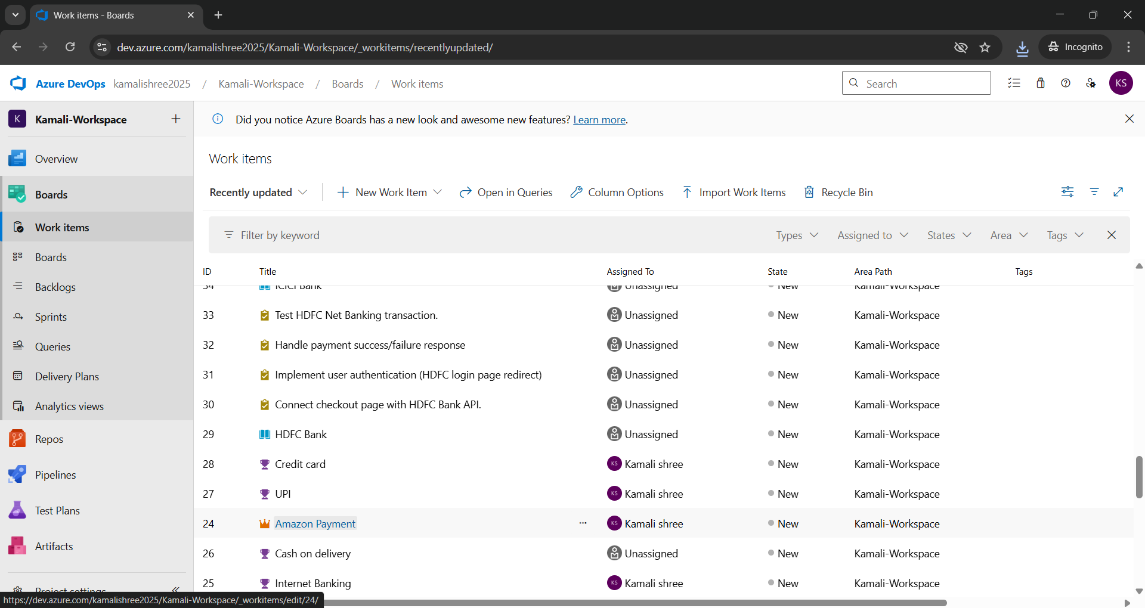

* **User Story 2 – ICICI Bank  
   *As a customer, I want to pay through ICICI Net Banking so that I can complete my purchase using my ICICI account.***
  + **Tasks:**
    - **Integrate ICICI API**
    - **Implement ICICI authentication**
    - **Handle transaction status response**
    - **Test ICICI Net Banking**
* **User Story 3 – SBI Bank  
   *As a customer, I want to pay through SBI Net Banking so that I can complete my purchase using my SBI account.***
  + **Tasks:**
    - **Integrate SBI API**
    - **Implement SBI login**
    - **Handle payment status**
    - **Test SBI transaction**

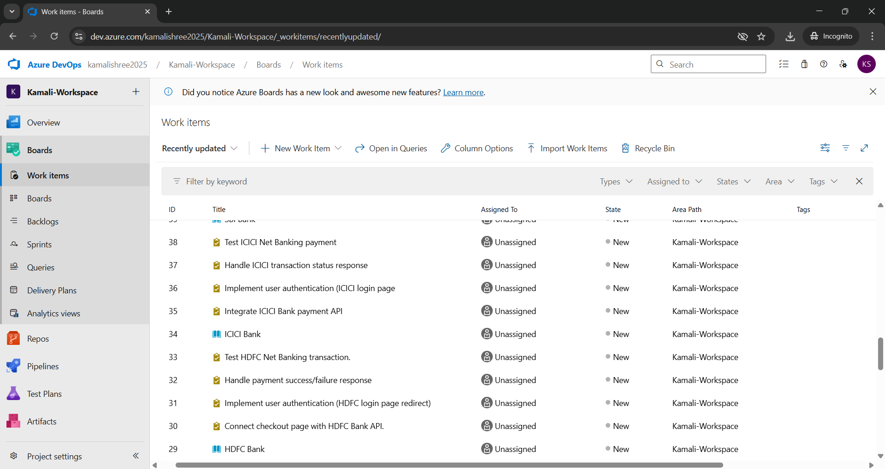

## **Feature 2: UPI**

* **User Story 1 – Google Pay  
   *As a customer, I want to pay using Google Pay (UPI) so that I can complete my purchase instantly.***
  + **Tasks:**
    - **Integrate Google Pay UPI API**
    - **Implement UPI ID/QR flow**
    - **Handle payment confirmation callback**
    - **Test GPay transaction**
* **User Story 2 – PhonePe  
   *As a customer, I want to pay using PhonePe (UPI) so that I can make secure UPI payments.***
  + **Tasks:**
    - **Connect PhonePe API**
    - **Handle UPI PIN authentication**
    - **Process success/failure response**
    - **Test PhonePe transaction**
* **User Story 3 – Paytm UPI  
   *As a customer, I want to pay using Paytm UPI so that I can complete my order using Paytm wallet/UPI.***
  + **Tasks:**
    - **Integrate Paytm UPI API**
    - **Implement wallet/UPI flow**
    - **Handle payment response**
    - **Test Paytm transaction**

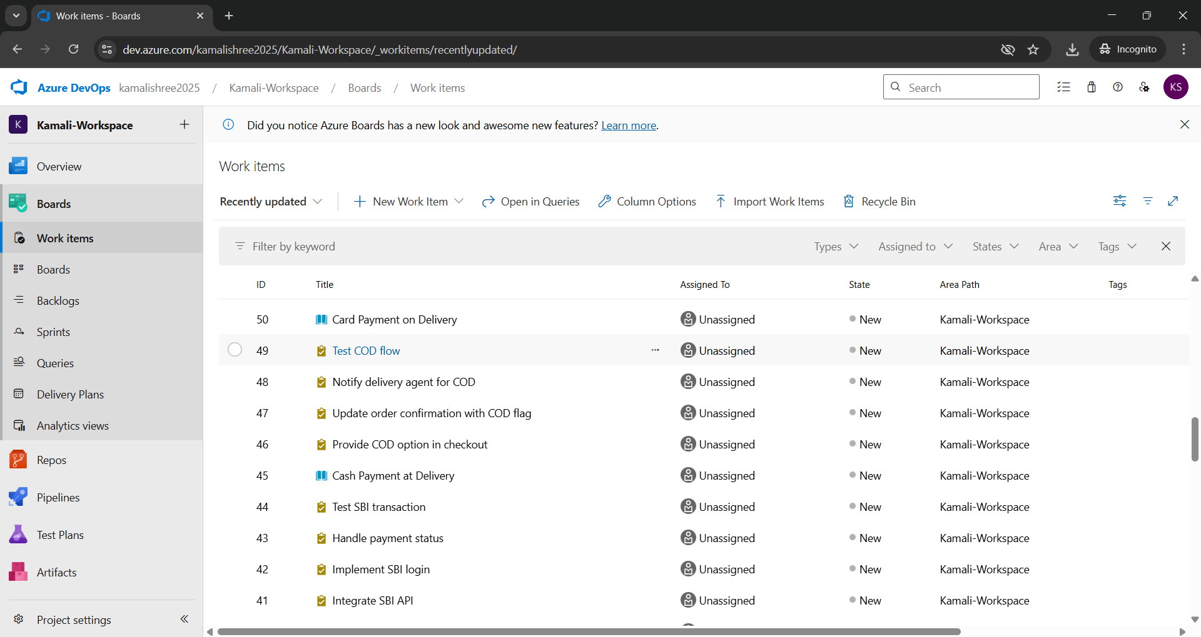

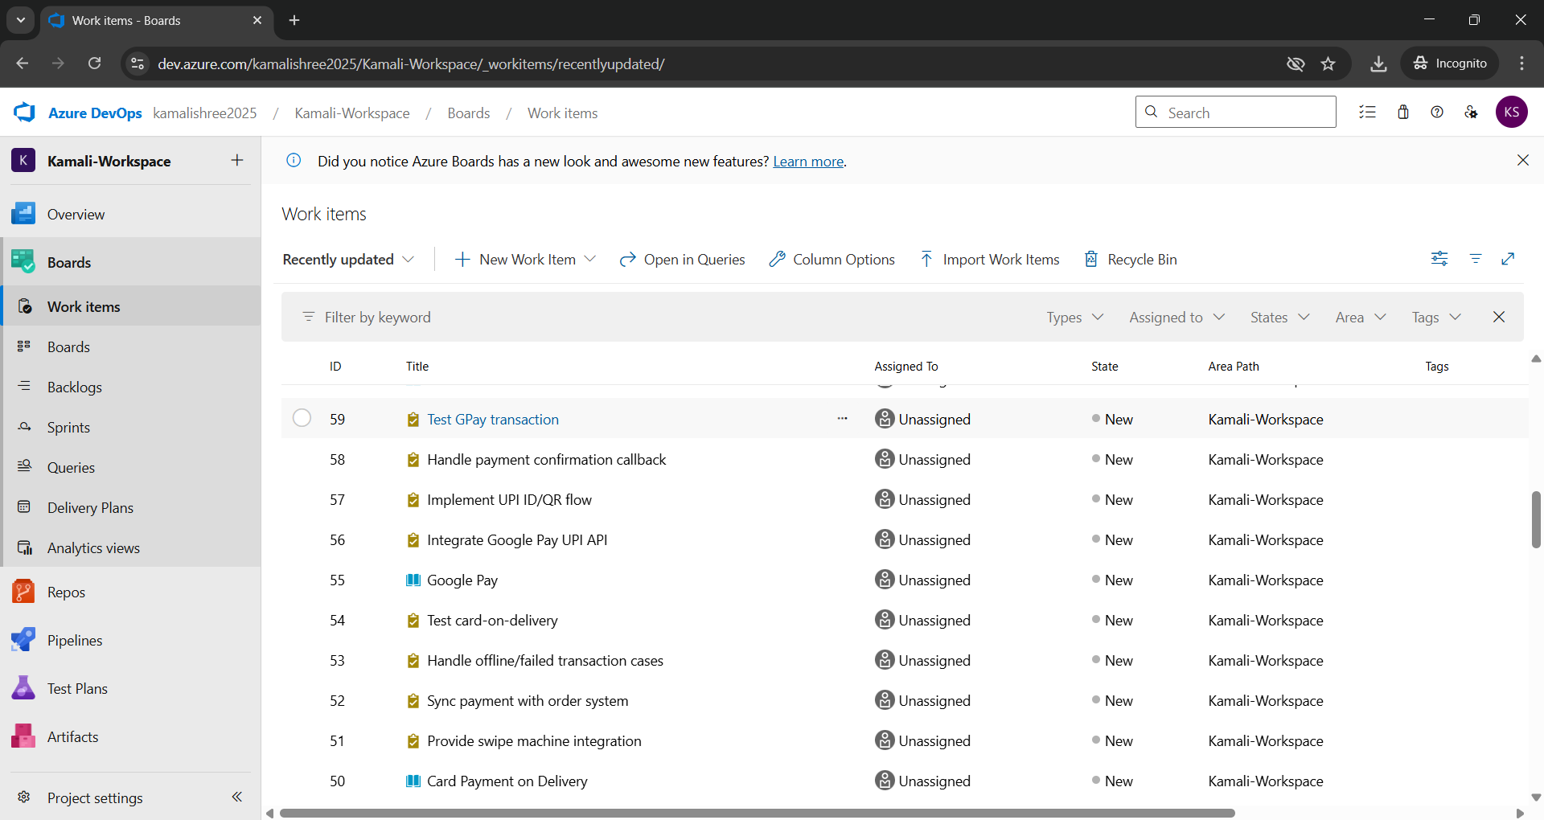

## **Feature 3: Cash on Delivery (COD)**

* **User Story 1 – Cash Payment at Delivery  
   *As a customer, I want to pay in cash to the delivery agent so that I don’t need to use online payments.***
  + **Tasks:**
    - **Provide COD option in checkout**
    - **Update order confirmation with COD flag**
    - **Notify delivery agent for COD**
    - **Test COD flow**
* **User Story 2 – Card Payment on Delivery  
   *As a customer, I want to pay via card at the time of delivery so that I have flexibility in payment mode.***
  + **Tasks:**
    - **Provide swipe machine integration**
    - **Sync payment with order system**
    - **Handle offline/failed transaction cases**
    - **Test card-on-delivery**

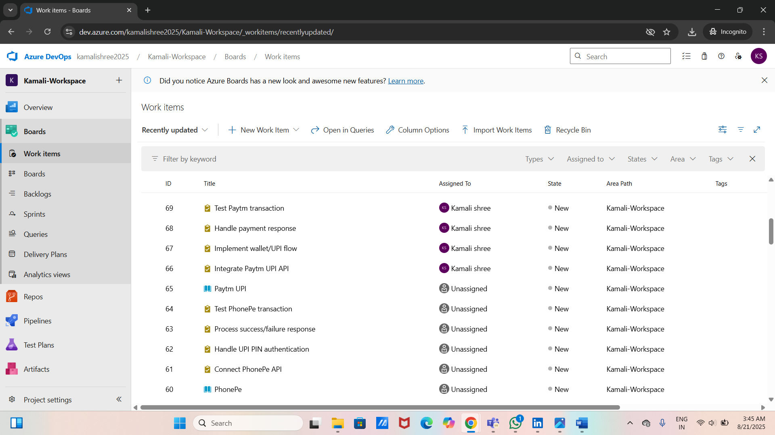

## **Feature 4: Credit Card**

* **User Story 1 – Visa Card  
   *As a customer, I want to pay using Visa credit card so that I can securely pay online.***
  + **Tasks:**
    - **Add Visa payment gateway integration**
    - **Implement card validation (number, CVV, expiry)**
    - **Handle success/failure callback**
    - **Test Visa transaction**
* **User Story 2 – MasterCard  
   *As a customer, I want to pay using MasterCard so that I can complete my purchase easily.***
  + **Tasks:**
    - **Integrate MasterCard API**
    - **Add 2FA/OTP authentication**
    - **Handle transaction status**
    - **Test MasterCard payment**
* **User Story 3 – American Express (Amex)  
   *As a customer, I want to pay using Amex card so that I can complete my purchase securely.***
  + **Tasks:**
    - **Integrate Amex payment API**
    - **Implement validation for Amex format**
    - **Handle response**
    - **Test Amex transaction**

